Report: Laboratory work 2

**Determining and removing drawbacks of exponential and running mean**

Team #1: Viktor Liviniuk, Alina Liviniuk

In this work we determine conditions for which broadly used methods of running and exponential mean provide effective solution and conditions under which they break down.

**Part 1. Backward exponential smoothing**

Backward exponential mean was determined as well as running mean. From visual comparison we made a conclusion that backward exponential mean is smoother than running mean. Is also does not have the drawback of forward exponential mean – delay.

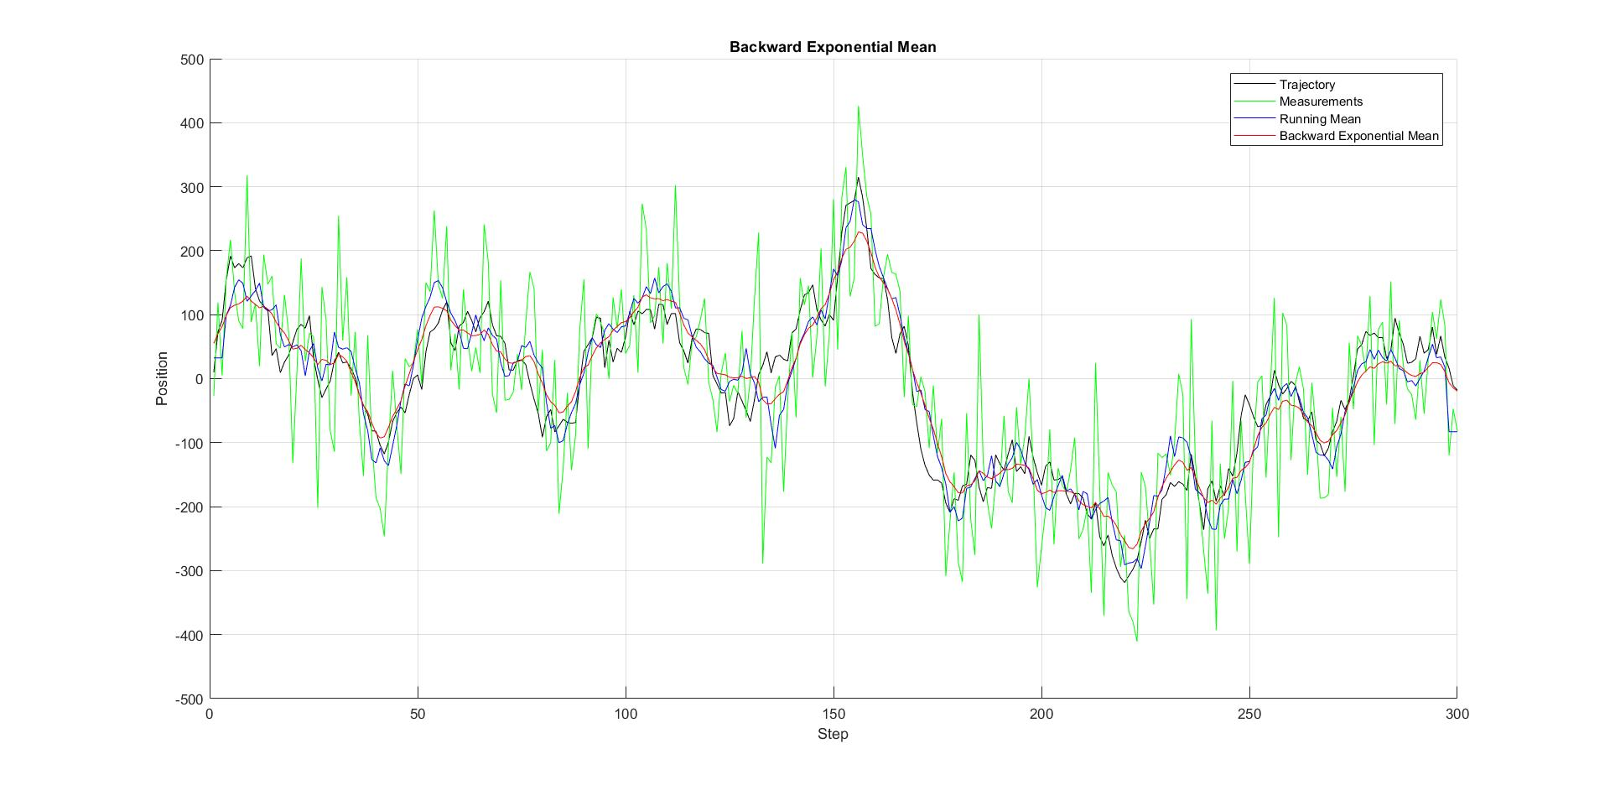

A zoomed region is on the following picture.

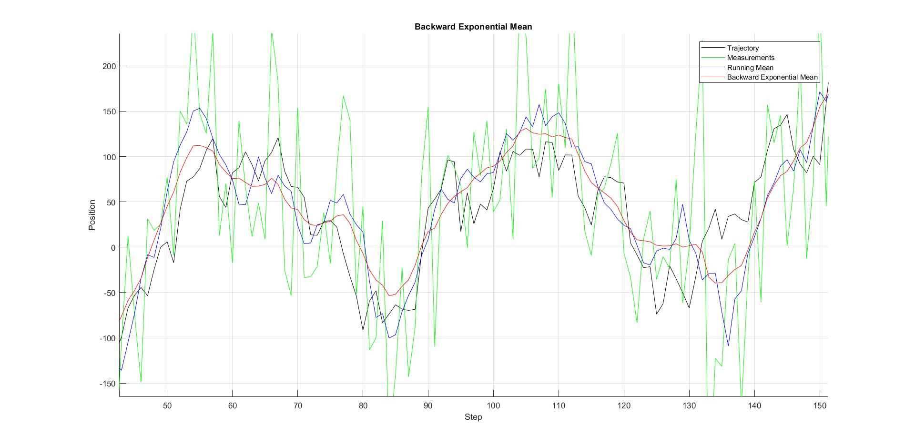

|  |  |  |
| --- | --- | --- |
|  | Deviation Indicator | Variability Indicator |
| Running Mean | 2.38e+06 | 2.40e+05 |
| Forward Exp. Mean | 2.11e+06 | 4.68e+05 |
| Backward Exp. Mean | 2.36e+06 | 1.63e+04 |

Table 1. Comparison of Indicators

Variability indicator for backward exponential mean is much lower that for two other methods. That means, it gives a smoother estimation. Deviation indicators are almost the same for all 3 methods, however for forward exponential mean it’s usually a bit lower.

In this particular kind of trajectory, it is hard to choose the best method. They all work well. If we know, that real trajectory is smooth, it backward exp. mean can be optimal.

**Part 2. Drawbacks of running mean**

We analyze two kinds of processes. First process’s rate of change is changed insignificantly and measurement noise is great. Second process is periodical with noise much lower that amplitude of change.

***First trajectory***

Object’s motion is disturbed by normally distributed random acceleration. The final trajectory is a smooth line, close to linear.

For running mean the higher the window size M is – the better. M = 101 works fine in the center of trajectory. It gives a relatively smooth curve. However, there is a problem with first and last steps estimation – they are taken as a mean of measured ones.

For exponential mean smoothing coefficient 𝛼 should be small, because we want previous steps to have a bigger effect on prediction of next steps, than highly distorted measurements. It was empirically chosen to be 𝛼 = 0.05.

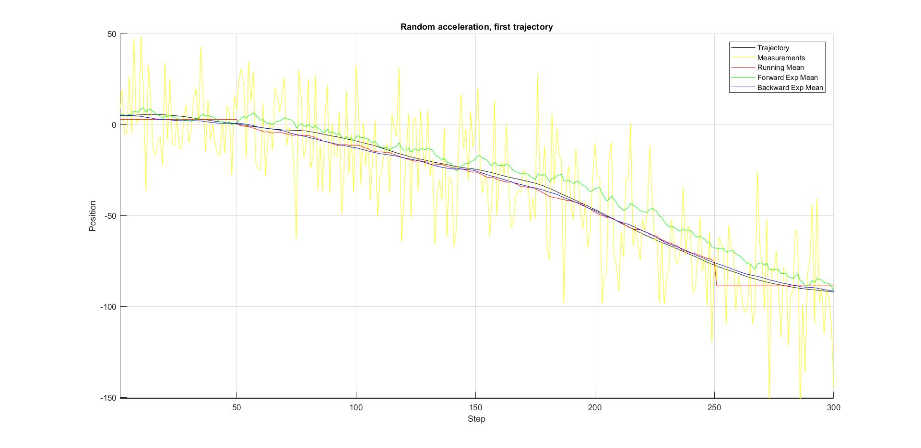

|  |  |  |
| --- | --- | --- |
|  | Deviation Indicator | Variability Indicator |
| Running Mean | 2.75e+06 | 2.64e+05 |
| Forward Exp. Mean | 2.14e+06 | 2.95e+05 |
| Backward Exp. Mean | 2.50 e+06 | 1.74e+04 |

Table 1. Comparison of Indicators for 1st trajectory

This trajectory demonstrates the backward exponential mean works great for smooth trajectories and eliminates measurement error in similar tasks. It is the best method for this type of measured value.

***Second trajectory***

We applied running mean with window size 𝑀=15 for the generated cyclic trajectory. We determined, that we get…

% inverse oscillations when T = 4, 8..13

% zero oscillations when T = 1..3,5

% insignificantly changed oscillations when T = 35..

1. inverse oscillations, when T = 8..13 (when approximately M = 1.5 T):

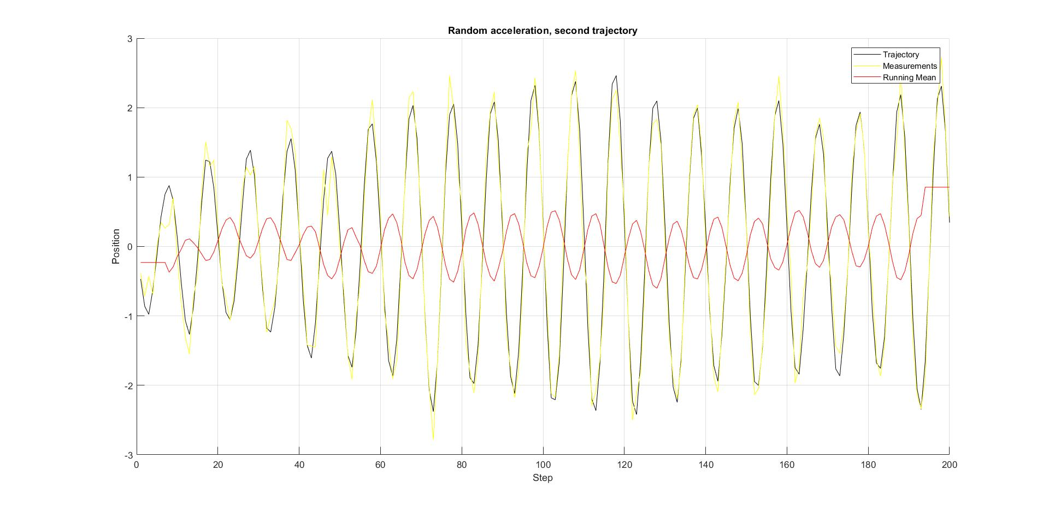

also, very interesting situation, when T = 4 (when M = 4T - 1):

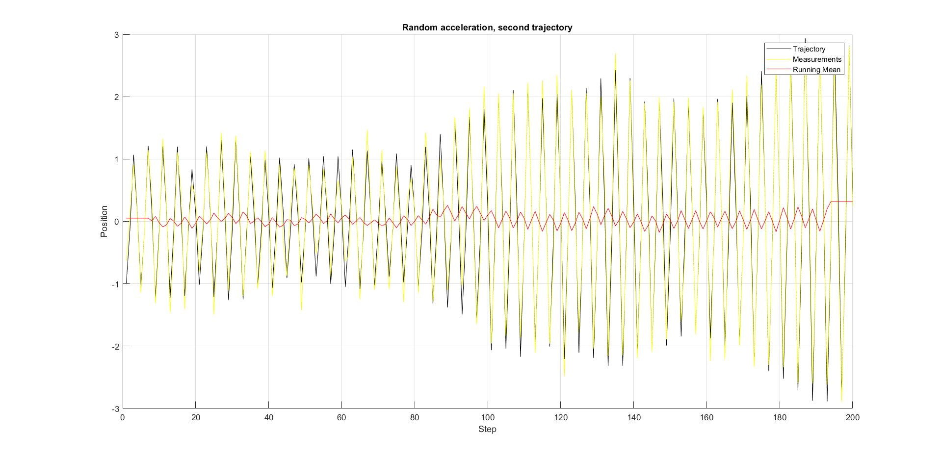

1. zero oscillations, when T = 1..5 (excluding 4):

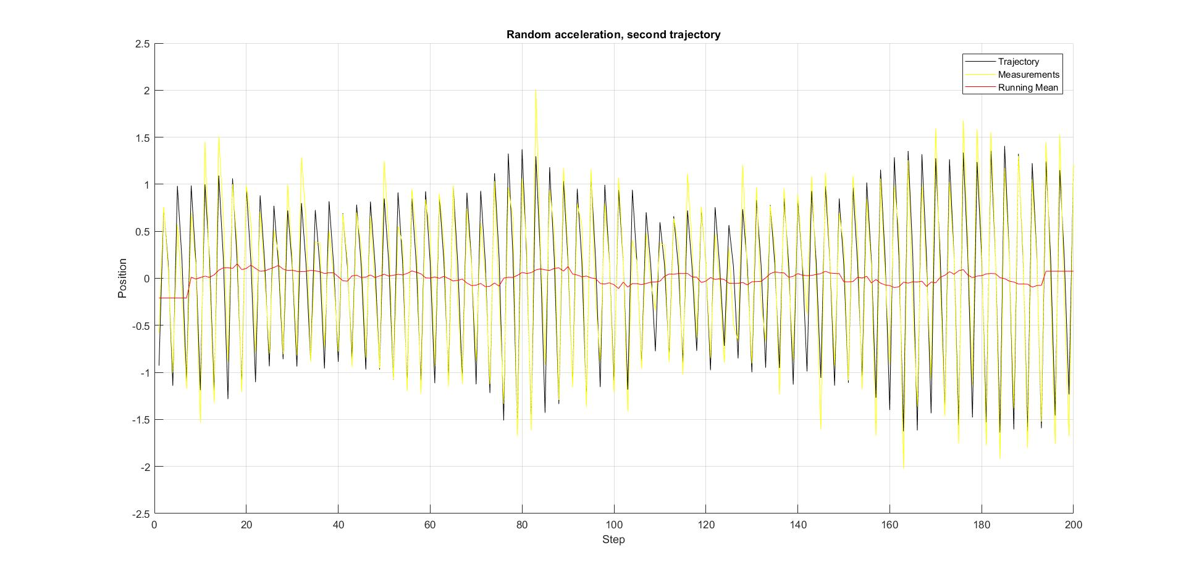

1. insignificantly changed oscillations, when T is high (T = 2M = 30 and more):

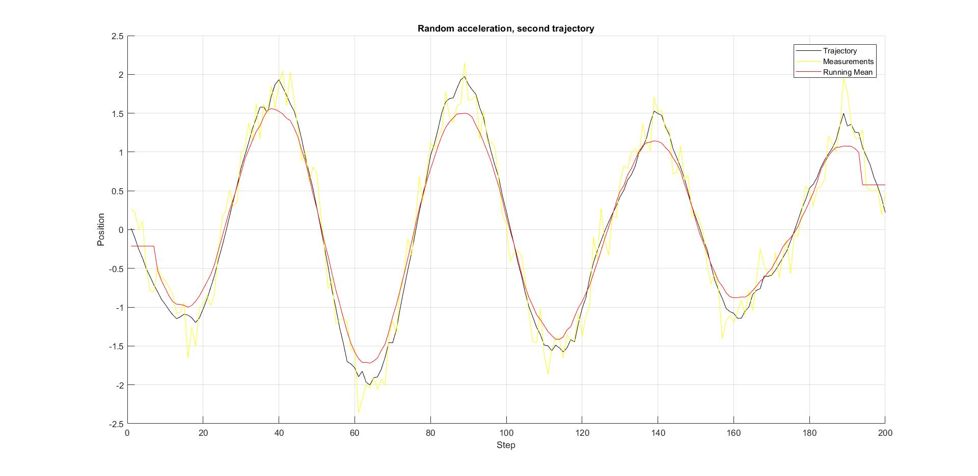

Conclusion.

Main drawback of forward exponential mean method, the shift, was eliminated in backward exponential mean method. The backward method works very good with smooth functions, when the measurement variance is large.

Deviation and variability indicators can be used as criteria for a good evaluation method. Backward exponential method showed good result, especially with variability indicator. This is because it gives smoother result, than running mean method.

When using running mean for evaluating periodical functions, one should remember it may give false results, like antiphase. It is due to overlapping of window size and some number of periods of the function.

Files with matlab code are attached.